Wonder 2nd – 5th June

Mon | Tues | Wed | Thurs | Fri
 | Read ~10pags  At least 1 Comp Q  2 vocab/phrases | Read ~10pags  At least 1 Comp Q  2 vocab/phrases | Read ~10pags  At least 1 Comp Q  2 vocab/phrases  Getting to Know R J Palacio:  Watch the R J Palacio Interview. http://www.viewpure.com/Wo2McU_S4GE?start=0&end=0  Read the Palacio’s FAQ Page.  Novel Copy:  - Write down 5 questions you’d like to ask the author.  - What do you think of the book? Has reading it changed you or your opinions in any way. Give a 5th/6th class answer ;)
Vocabulary and Key Phrases:
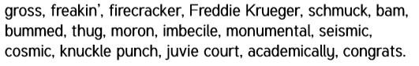

If you want to challenge yourself, the Deeper Reading questions on the right hand side make you think that bit more!
