Belgrove Senior Girls’ School

Board of Management

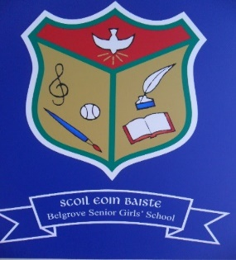

Belgrove Senior Girls’ School has a dedicated and hard-working Board of Management, which meets regularly. The Board has eight members, with equal representation from the Patron, the Teaching Staff, Parents, and the wider community.
Members of the Board are:
- Patron’s Nominees: Dr. P.J. Sexton (Chairperson) & Fr. Larry White
- Principal: Mrs. Anne McCarthy
- Teachers’ Nominee: Mrs. Katie Stokes
- Parents’ Nominees: Mr. Ross Breen & Ms. Ruth Fullam
- Community Nominees: Mrs. Bernadette Hollingsworth (Treasurer) & Mr. Shane Brodie.

The current Board of Management term of office runs from 1 December 2019 to 30 November 2023.

Governance Manual for Primary Schools 2019-2023
Section 8.3 - Important Note: Board members are not delegates of their electorates. They have no obligation to either report back to their electors or to take instruction from them on how to vote at board meeting.

