Wild Postcard Project

You have been doing lots of learning about biodiversity in your area recently and you’ve studied and observed many different species of birds and insects. If you have enjoyed learning about nature, you might be interested in this project!

This project requires you to create artworks depicting Ireland's biodiversity. Biodiversity is all living things in nature, including the animals, plants, and micro-organisms that comprise all life here in Ireland. The ten winning entries will be turned into postcards and will feature on the website – www.wildpostcardproject.com

Here is the information for entry below:

Submission Details:
1. WHO: The competition is open to kids and teens (ages 5 - 18) who are currently living in Ireland.
2. WHAT: The artwork (whether a painting, drawing, etc.) must represent the biodiversity of Ireland in some way…either a single animal or plant, or an entire habitat or landscape! Three-dimensional pieces (e.g. sculptures, paper maché, collages, etc.) or other kinds of creative entries are also accepted!
A digital copy of the artwork and entry form is preferred (take a photo with an iPhone, iPad, or any option that works!). Just make sure to hold on to the original copy of the artwork in case it is selected as a winning entry because we may need the original for printing purposes. Along with a photo of the artwork, please include the information as requested on our online entry form. Alternatively, the entry form information and artwork image can be submitted via email – send to wildpostcardproject@gmail.com
3. WHEN: No later than 24th June 2020
4. WHERE: Online entry form (available at www.wildpostcardproject.com)
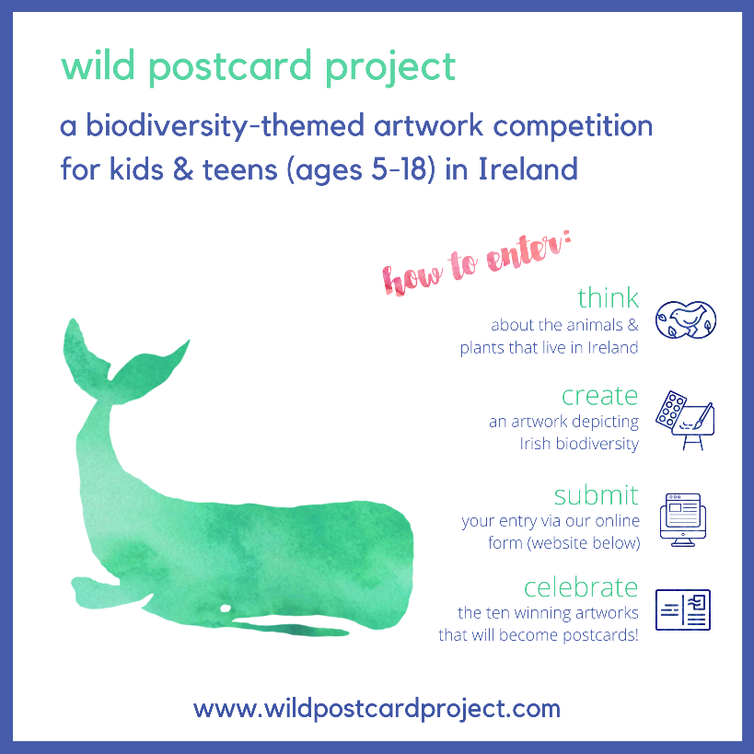
Trees
