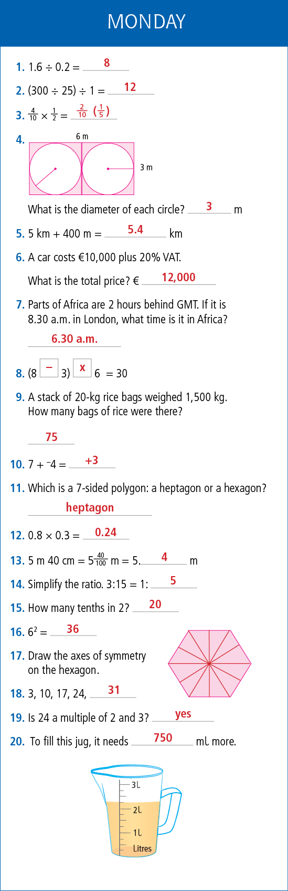- 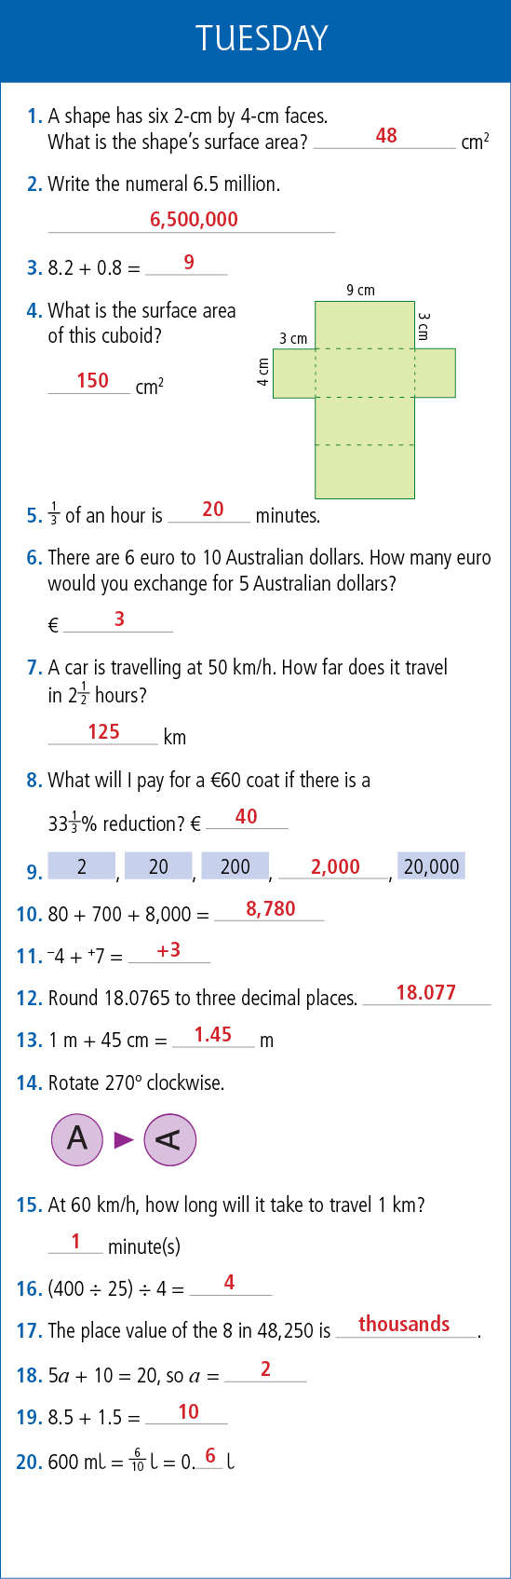

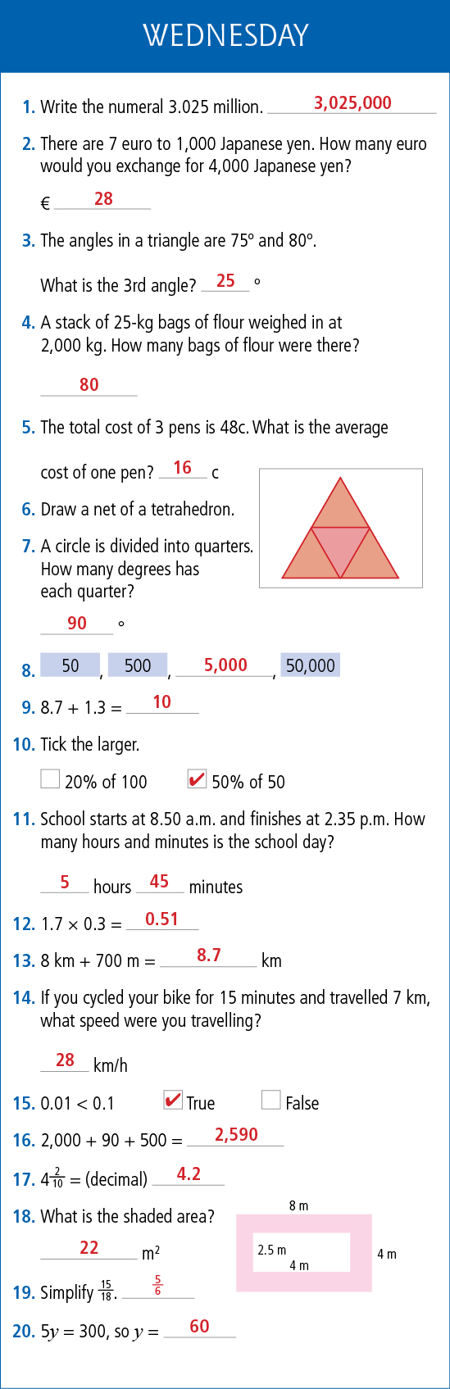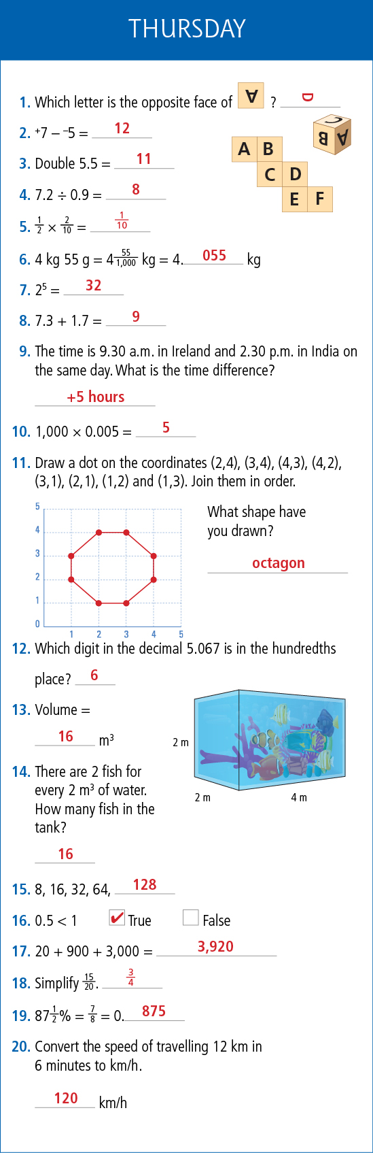

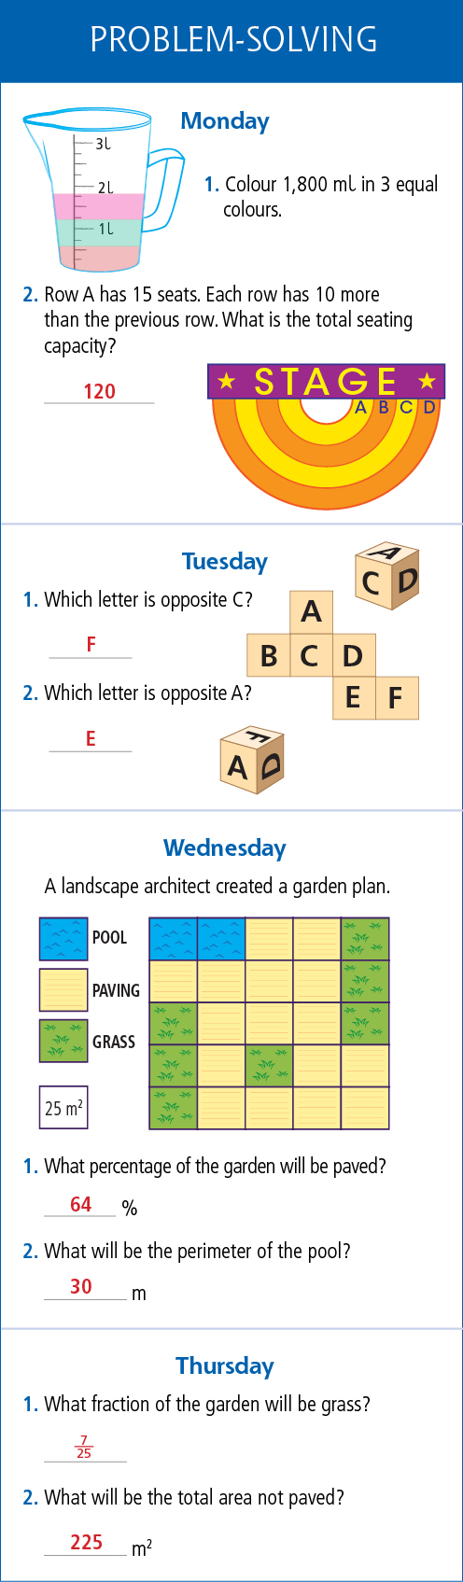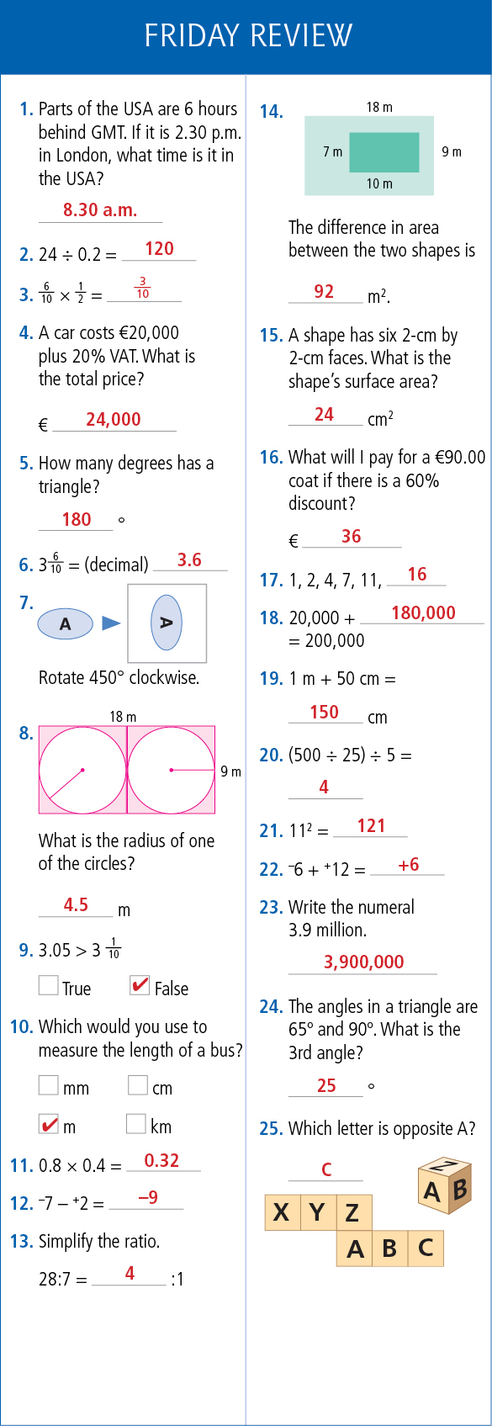

Shadow Book
Monday
Pg. 62 Q. 7
- 15
- 15
- 6
- 17
- 22
- 21
- 33
- 1
- 132
- 96
- 23
- 81
- 51
- 68
- 38
- 60.9
- 11.1
- 8

Shadow Book
Friday- page 28
Q1
- Always
- Never
- Never
- Always
- Always
- Always
- Always
- Sometimes
Q2
- Rectangle
- Hexagon
- Kite
- Rhombus
- Pentagon
- Isosceles Triangle

Shadow Book
Tuesday
Pg. 70 – A Quick Look Back
- 6561
- 50
- 300kg
- (a) 7 (b)15
- 53.38cm
- 7004g
- 484 square cm
- 900
- €672
- €200
- 6
- 25:75 or 1:3
- 4 1/7
- 25,150
- 142.052
- (a) Triangular prism (b) 5
- 20
- 3.552
- €168
- 6.048L

Shadow Book
Friday- page 28
Q4.
- Rectangle
- Square
- Isosceles Triangle
- Trapezium
- Heptagon

Wednesday Maths
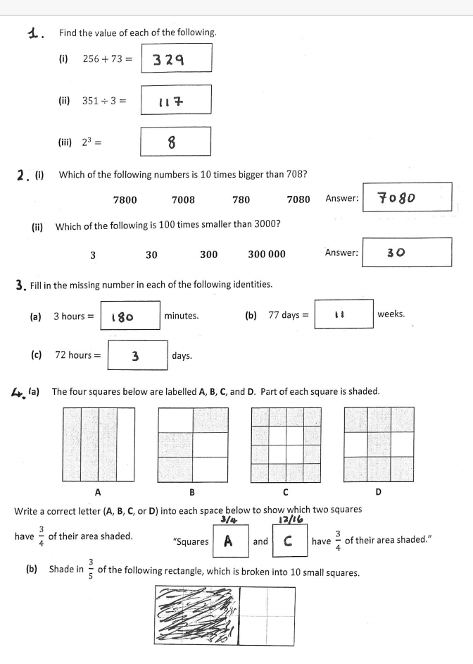
Harry Potter - Tuesday
Section B
Ron had great difficulty hiding his feelings as he looked enviously at Harry. He wasn’t allowed to unwrap any presents in public. Even though Ron and Harry were known for arguing over little things, this time they grinned at each other. They now had the latest model of broomstick, which was designed to resist all spells.

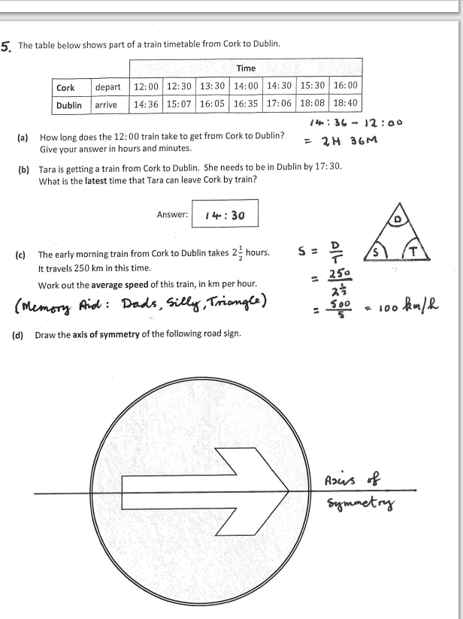

1. C – focus
2. C – confiscated
3. A – combination
4. C- category
5. B – events
6. C - terror
7. B – apparent
8. C – mix-up
9. C – flabbergasted
10. C- squealed

Jolly Phonics pg. 99 - Tuesday

The two friends reached an agreement after their argument.
Subject Verb Object
friends reached agreement
the, two after their argument an

Ed Sheeran Comprehension
Q7 – Put events in order
1. He moved to Suffolk
2. He began writing songs at high school
3. He moved to London
4. He was spotted by Jamie Foxx
5. The album ‘+’ was released
6. Spotify named him the most streamed artist and ‘x’ the most streamed album of 2014
7. He won an Ivor Novello Award for Songwriter of the Year
8. He released ‘÷’

Gaeilge
Abair agus Beir: an Aimsir Fháistineach
1. Béarfaidh mé ar mo cheapaire chun é a thabhairt abhaile.
2. Déarfaidh an bainisteoir gur imir an fhoireann go maith amárach.
3. An mbéarfaidh sé ar a chluasáin chun éisteacht le ceol?
4. Ní déarfaidh sí léi nuair a éireoidh sí tuirsearch.
5. Béarfaidh siad ar t-léinte nuair a bhíonn siad sa díolachan.
6. An ndéarfaidh sé ‘Ciúnas’ go minic sa somra ranga?
7. Béarfaimid ar an liathróid go tapa.
8. Déarfaimid go bhfuil an bia ar an mbia is fearr an domhan.
9. Ní bhéarfaidh sí ar a bosca lón ag dul amach maidin amárach.
10. Déarfaidh mo dheartháir go bhfuil sé lán béal.

Tír na nÓg – Ceisteanna lch. 131
1. Oisín ab ainm don laoch sa scéal./Oisín ab ainm dó.
2. Bhí sé amuigh ag fiach nuair a chonaic sé an chapall bán.
3. Bhí cónaí uirthi i dTír na nÓg./Bhí sí ina cónaí i dTír na nÓg.
4. Ní dheachaigh aon duine in aois ann. Bhí rogha gach bia ann. Ní raibh tinneas ná bás ann. Bhí áthas ar gach duine an t-am ar fad. Srl.
5. Bhí uaigneas ar Oisín. /D’éirigh Oisín beagáinín uaigneach.
6. Dúirt Niamh leis gan cos a chur ar thalamh na hÉireann.
7. Bhí Oisín croíbhriste nuair a fuair sé amach go raibh a athair agus a chairde marbh.
8. Thit Oisín den chapall agus d’éirigh sé sean. Fuair sé bás ar thaobh an bhóthair.

Abair Liom lch. 149
Gramadach: Uatha agus iolra
2. deochanna
3. Dathanna
4. Ranganna
5. Marcanna
6. Clubanna

Abair Liom lch. 149
Na Fuaimeanna ‘t’ agus ‘th’
Giotár ceathair bláthanna tuismitheoirí
Bhí sé thar a bheith greannmhar nuair a thit Síofra tóin thar ceann.

