Wonder Comprehension Questions
We will be reading p153-183 starting on Tuesday 5th May. If we read about 7 or 8 pages a day we should reach p183 by Friday! Just do a little reading every day.
You can read the book over the weekend to catch up on reading if you don’t get it all read during the week.
After your daily reading, try to answer one or two of the comprehension questions and complete dictionary work on 2 of the vocab/phrases. Look at the page numbers to guide you.
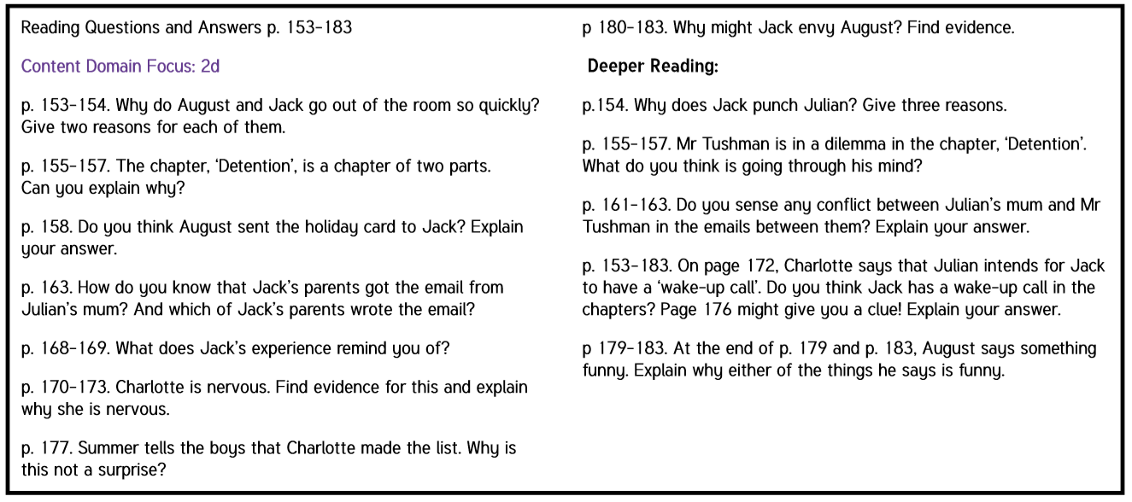
Write the question out in red pen in your novel copy with your answer underneath. Give as much detail as you can and don’t forget to always PQA (Put the question in the answer).

Choose at least 2 new words/phrases a day. Write down the dictionary meanings of new vocabulary in your novel copy.
