MM and BAM Capacity Answers p 170-173
Warning! Correct p171 Q1g first: the answer is wrong- should be 920/1000 L= 0.920 L
I found a new way of downloading the mental maths answers!
It seems very clear so I hope you find it easier to correct
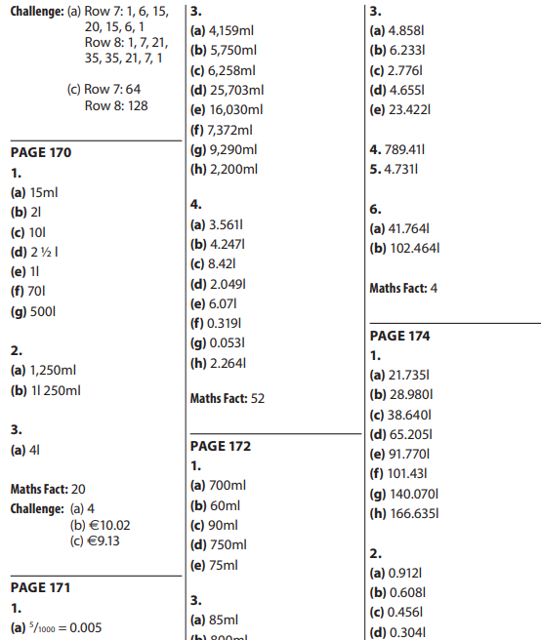
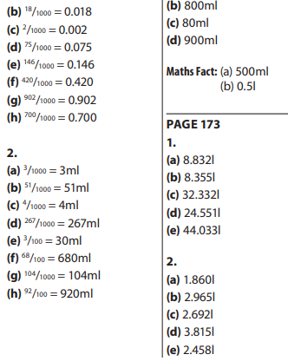

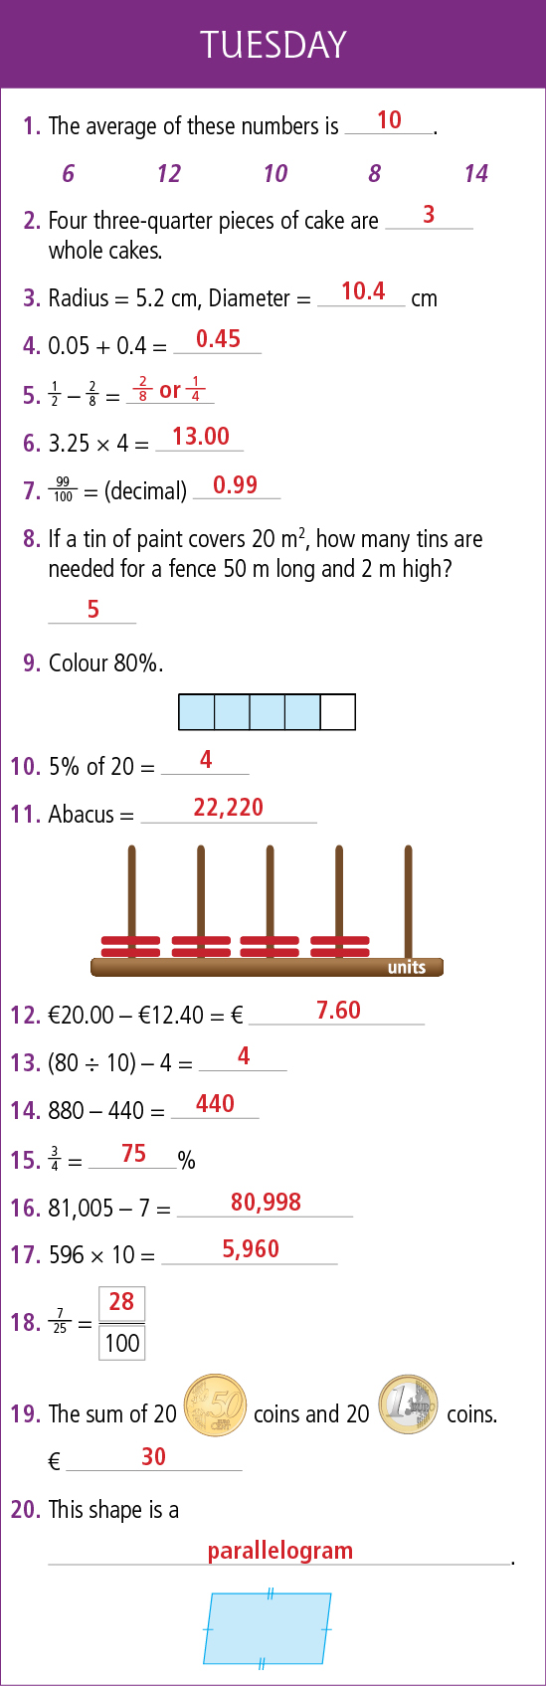
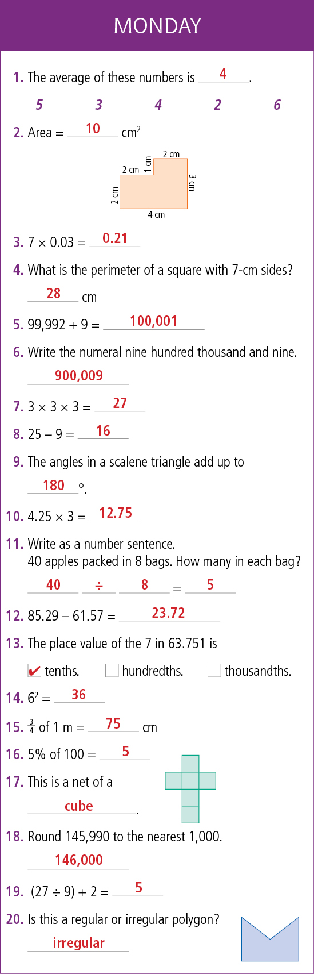
1
