2. The Circle Information
Circumference= The circumference is the distance once around the circle.
Arc= A part of the circumference is called an arc.
Diameter= The diameter goes straight across the circle, through the centre.
Centre Point= The centre of a circle is the point which is at equal distances from all points on the circle.
Sector = The part of a circle enclosed by two radii of a circle and their intercepted arc. The "pizza" slice is called a sector.
Radius = The radius is the distance from the centre outwards
Segment= The segment, which is cut from the circle by a “chord” (a line between two points on the circle)
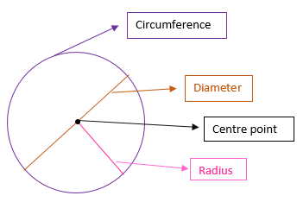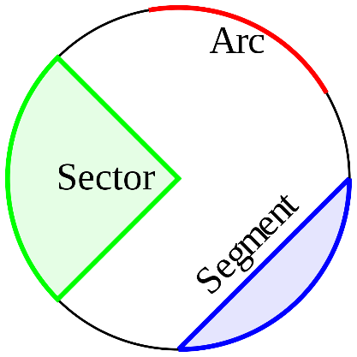
Radius, Diameter and Circumference
Radius= Diameter $÷$ 2
Example: The diameter of a circle is 8cm. What is the radius of this circle?
Radius= 4cm. Why? I know the diameter is 8cm and I know that half of the diameter is equal to the radius. Therefore the radius= 8cm $÷$ 2= 4cm
Diameter= Radius X 2
Example: The radius of a circle is 3cm. What is the diameter of this circle?
Diameter= 6cm. Why? I know the radius is 3cm and I know that the radius is double the diameter. Therefore, the diameter= 3cm X 2= 6cm
Circumference= Diameter X 3.14
Example 1: The diameter of a circle is 12cm. What is the circumference of this circle?
Circumference= 37.68cm. Why? I know the circumference is found by multiplying the diameter by 3.14. Therefore, the circumference= 12cm X 3.14= 37.68cm
Example 2: The radius of a circle is 4cm. What is the circumference of the circle?
Circumference= 25.12cm. Why? I know the circumference is found by multiplying the diameter by 3.14. I know the radius=4cm. Therefore, the diameter is 8cm. Circumference= 8cm X 3.14= 25.12cm

3. The Circle Questions

1. What part of the circle is represented by each letter?
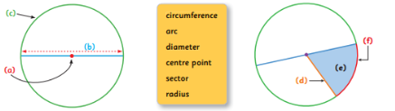
Circle | Radius | Diameter
A | 6cm | 12cm
B |  | 10cm
C | 2.5cm
D |  | 22cm
E |  | 65cm
Circle | Radius | Diameter | Circumference
F | 6cm | 12cm | 37.68 cm
G |  | 14cm
H | 4.5cm
I |  | 44cm
J |  | 52cm
2. Complete the two tables. The first one is done in each table as an example. Remember: Circumference= Diameter X 3.14

3. You walk around a circle once which has a diameter of 100m, how far have you walked? (Hint: What am I looking for? The circumference of the circle!)
4. Charlotte measures the distance from the centre of a circular garden to its edge and finds it is 43 metres. How long is the path which goes around the outside of the garden? (Hint: The radius is 43m)
5. True or False- The Circumference of a circle is the same as the area of a circle.
6. What term is used to describe half of the diameter?
7. What term is used to describe the part of a circle enclosed by two radii of a circle and their intercepted arc (the "pizza" slice)?
8. How many degrees are there in a circle?
9. Write out the definitions of the different parts of the circle- Diameter, radius, circumference, centre point, arc, sector and segment. You can use the definitions from the ‘Information on the Circle’ sheet. (Do in Maths copy)
10. Draw out the circle and label the different parts of it- Diameter, radius, circumference, centre point, arc, sector and segment (Do in Maths Copy)
4. Data 2- Cliffs of Moher

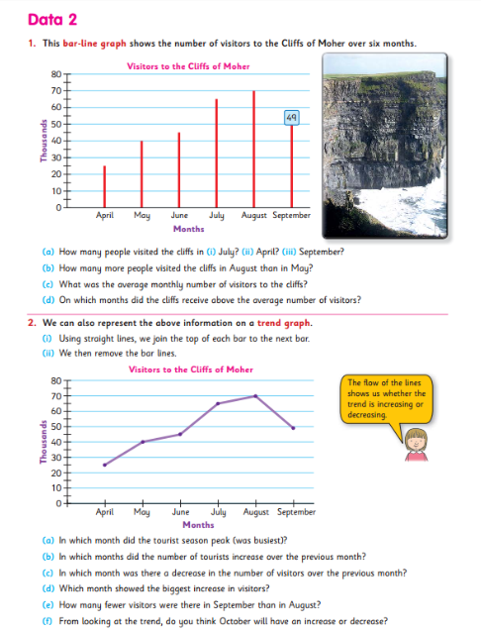
5. Data 2- Family Barbecue and Amy’s Reading
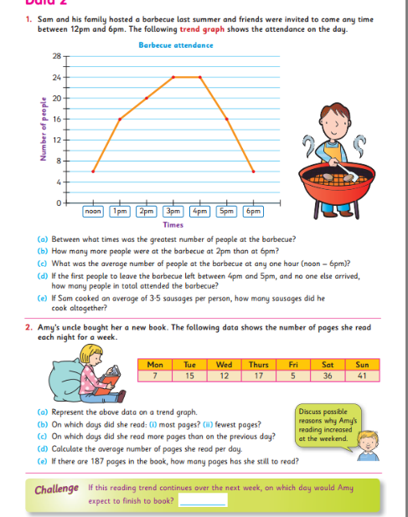

6. Data 2- Jolly Umbrellas
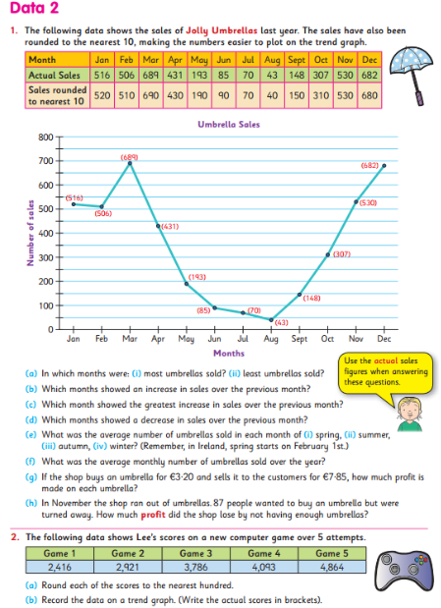

7. A Quick Look Back
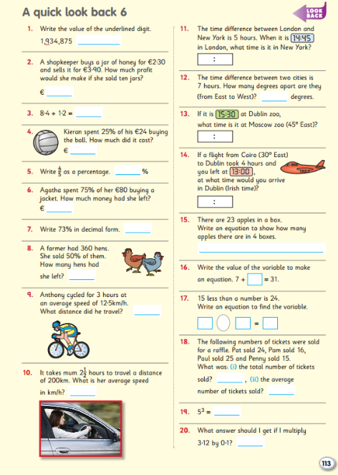

8. Gaeilge New Words

Focail/Frásaí Nua
www.focloir.ie
Abair Liom lch. 114
Ag cnagadh - knocking
Ar na doirse – on the doors
Ag leagan – blowing down
Slinnte – tiles/slates
Anuas - down
Díon - roof
Teideal - title

Abair Liom lch. 115
Siar is soir – up and down
Tír - land
Muir - sea
Gan traochadh – without exhaustion
Guth - voice
Go hard - loudly
In aon bhall - anywhere
Thar muir anon – across the sea
Go héasca - speedily
Riamh - before
Sliabh - mountain
Go dian – hard
Beireann – blow

11. My Dog Has Got No Manners
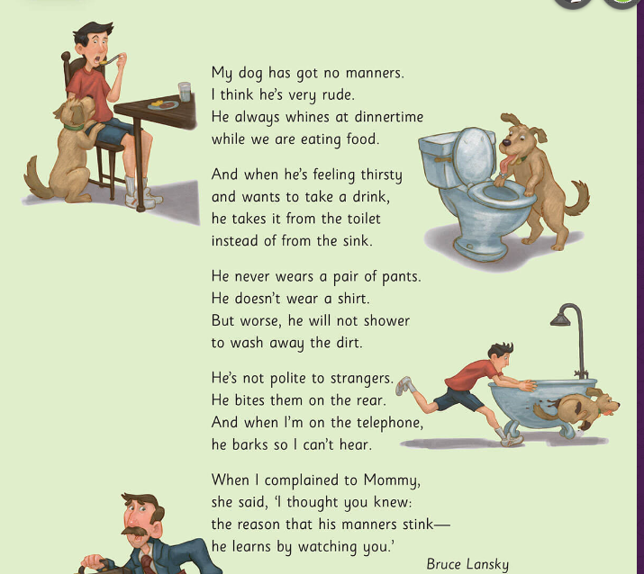
12. My Dog Has No Manners- Questions
1. What is the name of the author of this poem?
2. List the things you like about the poem.
3. What is the mood of the poem?
4. What are the images in the poem? Order them, starting with your favourite.
5. List the rhyming words in the poem.
6. What does this dog always do at dinner time?
7. Where does this dog get his water to drink?
8. How does the dog act towards people he does not know?
9. Now it’s time for you to create your own poem! It can be based on your own pet or another animal which has no manners! Don’t forget to include an illustration to go with your poem!

13. The Present Tense and The Present Continuous
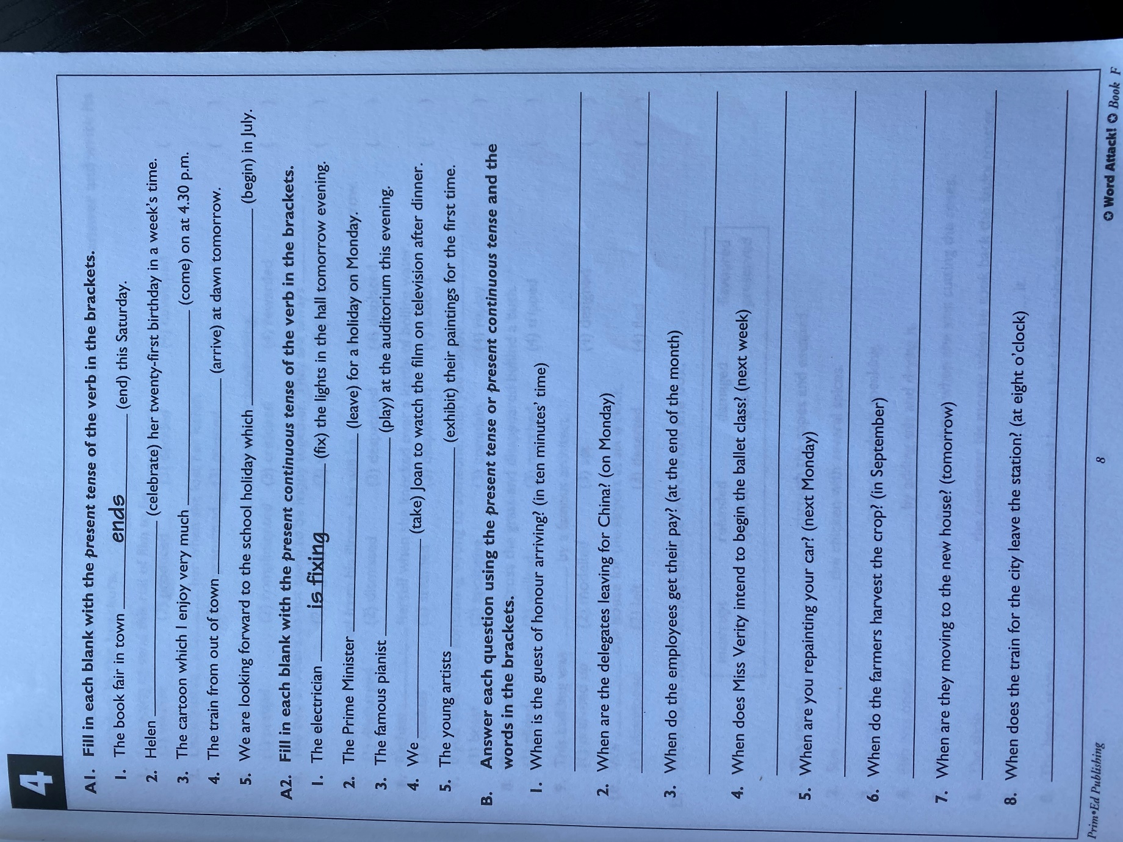

17. Positive Emotions Sheets-Sheet 1
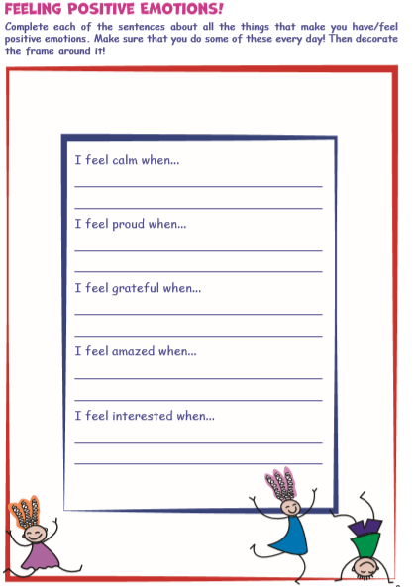

17. Positive Emotions- Sheet 2
