Wonder Comprehension Questions
We will all start reading from p85 on Monday 20th April. If we read about 6 or 7 pages a day we should reach p110 by Friday!
As you continue reading, answer the questions you feel you can. Look at the page numbers to guide you!
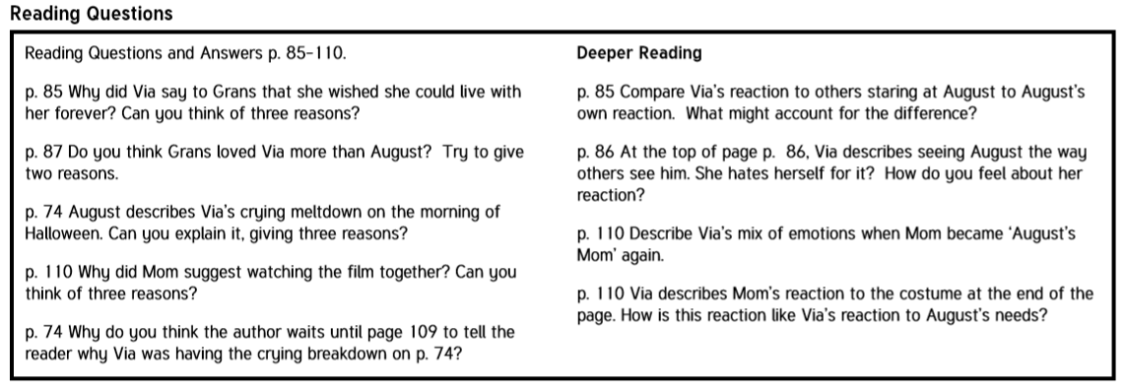
Write the question out in red pen in your novel copy with your answer underneath. Give as much detail as you can.

Choose at least 2 new words/phrases a day. Write down the dictionary meanings of new vocabulary in your novel copy.
