Ms Walshe’s – Home Learning, 20th-24th April 2020
This week, the 3rd Class teachers have laid out your learning for the week in a daily schedule grid. It’s at the very end of this message. Please organise your day to suit your family and your household.
Do as much as you can from the list each day. Try your best, but if you can’t do something, move on to the next thing on your list. Déan do dhícheall!
Maths:
- Ensure you’ve corrected any Maths work you did before the Easter holidays. Answers on 3rd Class blog.
- Complete the Busy at Maths (BaM) activities in your copy. *If* you have the facilities at home, you may photocopy/print the page and write the answers on it.
- Access online tutorials at https://my.cjfallon.ie/dashboard/student-resources
- Keep practising your tables (+, -, x, division), using online games, or by getting someone to quiz you.

English
- English Writing
  - Continue reading (6 pages) and summarising (3-4 sentences) The Owl Who Was Afraid of the Dark in your Red Stripe copy.

If you have finished the book, work on one or both of these writing activities. You practised them on World Book Day and for the Book Review competition, so I know you’ll do a great job. Please print the Character Profile/Book Review page from the class blog, or write into your Red Stripe copy using the headings/sentences starters on the Profile/Review pages.

- Book Review on The Owl Who Was Afraid of the Dark. (This might take 3-4 days to do really well).
- Character Profile on Plop, the Owl. (This might take you 1 or 2 days to do really well.)
- Go With the Flow C: Handwriting. 1 page per day.
  - Remember good handwriting posture – feet on the floor, sit up straight, use your spare hand to keep your book steady. · This website shows how to form letters http://data.cjfallon.ie/resources/gwtf-handwriting/index.html#!/
  - Click ‘Letter Formation’ and choose the letter you want to practise.
- Dictionary Work - Write the definition in your Red Stripe copy.
- Jolly Grammar
Remember:
- Homophones: our (belongs to us); are (to be, eg I am, you are)
- Homophones: there (in that place), their (belongs to them), they’re (they are)

Gaeilge
- As you’ve had a break of two weeks, this week, we’ll revise some of what you did before Easter.
- See Class Blog for how to access Abair Liom online through www.folensonline.ie
- Foclóir (Vocabulary) sheet with translations for Aimsir (weather) chapters in Abair Liom available on School website, under Subjects/Gaeilge http://www.belgroveseniorgirls.ie/wp-content/uploads/2020/04/AL-Rang-34-An-Aimsir.pdf

SESE - History
- Continue with Egyptians/Vikings Project (see Class Blog). Take care to follow the instructions!
- Since we won’t be back at school this month, you have more time to work on your Viking project!
- Check out the class blog to see really cool videos to help you learn about the Vikings in Dublin.

SESE –Science
Tree Hunt Activity
- Next time you are out for a walk, see how many different types of trees you can identify.
- You can identify trees by their
- Leaves https://www.woodlandtrust.org.uk/media/48345/leaf-id-sheet.pdf
- Twigs and buds https://www.woodlandtrust.org.uk/media/48347/twig-id-sheet.pdf
- Blossoms/catkins https://www.woodlandtrust.org.uk/media/48350/blossom-and-catkin-id-sheet.pdf
- Fruits and seeds https://www.woodlandtrust.org.uk/media/48348/fruits-and-seeds-id-sheet.pdf
- Which is the best one to use for this time of year, do you think?
- You could try to play Bingo with the ID cards, and see who is first to spot every one!
- Here is a really good PodCAST on Trees on the RTE School Hub called Hidden World: Forests, and some of it is based in St. Annes park! https://www.rte.ie/radio/radioplayer/html5/#/podcasts/21749664
PE - Choose from one of the following:
- Go for a walk (and see what trees you can identify on the way!)
- Pick an activity from the PE grid in Week 1
- Select a dance or exercise from https://app.gonoodle.com/
- PE with Joe on Youtube (20-30 min exercise class, streamed live at 9:00 am – ideal for all the family)
Music –
Bare Necessitities – See Class Blog
If you have the bare necessities, you have just what you need to survive. Baloo is very content to have just what he has. If you have a home, food to eat and people around you that love you, you are pretty lucky!

Art
- Viking Longship: Did you make a longship before Easter? Use this template or create your own. http://downloads.bbc.co.uk/history/handsonhistory/vikings_longship.pdf
- Plop Portrait: Use recycled materials, or things you find around the house to create a collage, drawing, print or model of the baby owl from The Owl Who Was Afraid of the Dark.

SPHE
Weaving Well Being journal – see Class Blog

Religion
- See Pentecost video on Class Blog
- Read Grow in Love, p64: The Story of Pentecost (yellow box)
- To access Grow in Love online, log on the www.growinlove.ie website with the following details:
Email: trial@growinlove.ie Password: growinlove
RTE School Hub 11:00 – 12:00 Monday to Friday. 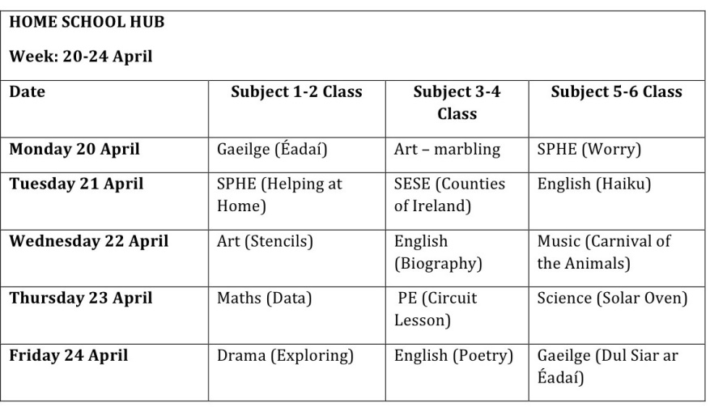
Subject | Monday | Tuesday | Wednesday | Thursday | Friday
Maths | BaM p115  3D Shape  Tutorial 64  MM: Wk 27- Mon | BaM, p116  3D Shape  Tutorial 65  MM: Wk 27 -Tues | BaM, p117  3D Shape  MM: Wk 27-Wed | BaM, p118  3D Shape  Tutorial 66  MM: Wk 27 -Thur | MM: Wk 27 -Fri Review  Correct work.
English | The Owl- Read 6 pages.  Pick one: (see above)  - Summary  - Book Review  - Character Profile  Go with the Flow: 1 page  Dictionary work in Red Stripe copy:  vehicle, saddle  DEAR diary – read library book for 15 mins – 1 line of grid + 1 top box  Jolly Grammar, p59 (1st half) | The Owl … Read 6 pages.  Pick one:  - Summary  - Book Review  - Character Profile  Go with the Flow: 1 page  Dictionary work in Red Stripe copy:  Aquatic, quiver  DEAR diary – read library book for 15 mins – 1 line of grid + 1 top box  Jolly Grammar, p59 (2nd half) | The Owl … Read 6 pages.  Pick one:  - Summary  - Book Review  - Character Profile  Go with the Flow: 1 page  Dictionary work in Red Stripe copy:  Equipment, quarrel  DEAR diary – read library book for 15 mins – 1 line of grid  Jolly Grammar, p61 (1st half) | The Owl … Read 6 pages.  Pick one:  - Summary  - Book Review  - Character Profile  Go with the Flow: 1 page  Dictionary work in Red Stripe copy:  Desert, laser  DEAR diary – read library book for 15 mins – 1 line of grid + 3rd box (dictionary words) | The Owl … Read 6 pages.  Pick one:  - Summary  - Book Review  - Character Profile  Go with the Flow: 1 page  Dictionary work in Red Stripe copy:  Business, easel  DEAR diary – read library book for 15 mins – 1 line of grid + 4th box  Jolly Grammar, p61 (2nd half)
Gaeilge | Abair Liom E (online) Lesson 15 An Póstaeir15  Scéal (listen first then read along or by yourself)  Foclóir (matching Activity)  Amhrán- Ag Cur Báistí Arís Abair Liom (book or online ebook)  Lch 124 –highlight the fadas, and read the story | Abair Liom E (online) – Comhrá 15 – listen, then read along  Comhrá ,AL lch 125 - highlight the fadas, and read  Lch 125 C – Cén Sort Aimsir É? Answer questions 1+2 about the weather today, yesterday. Give it your best try. | Abair Liom E (online) – Comhrá 15 – listen, then read along  Eiseamláirí (Expressions) – Listen and read  Comhrá ,AL lch 125 and read  Lch 125 C – Cén Sort Aimsir É? Ceist 3+4 about what weather you do and don’t like. | Abair Liom E (online) – Comhrá 15 – read along, or on your own  Eiseamláirí (Expressions) – Listen and read  Comhrá AL lch. 125 Comhrá - Read. Can you do actions to show what each sentence means?  Lch 125 C – Cén Sort Aimsir É? Q 5+6 about what activities you can do in certain weather. | Abair Liom E (online) – Comhrá 15 - Eiseamláirí  Comhrá, AL lch 125 - Read. Can you do different voices for each character, and do actions to show the meaning?  AL lch 126 E  an = VERY  When you say very in Irish, you put a h after the first letter of the adjective, eg very big = an mhór
SESE | Viking Project  See Viking Project blog, posted on 30 March for details.  Watch videos on Learn About the Vikings blog, posted 20 April | Viking Project  Working on your project plan:  Reread Unlocking SESE, Chapter 15? Have you planned how you will answer the questions in Section A? | Viking Project  Working on your project plan:  Have you decided which two topics you will research for Section B?  The videos on Learn About the Vikings blog, posted 20 April might be really helpful | Viking Project  Working on your project plan:  Have you decided which two topics you will research for Section C? | Science – Tree Hunt Activity.  See details above.  You can do this activity any day, even the weekend. You could do it more than once.
PE | Choose an activity from above | Choose an activity from above | Choose an activity from above | Choose an activity from above | Choose an activity from above
Your choice: | Religion, Art, Music or SPHE  See details above | Religion, Art, Music or SPHE  See details above | Religion, Art, Music or SPHE  See details above | Religion, Art, Music or SPHE  See details above | Religion, Art, Music or SPHE  See details above

