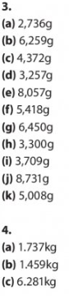  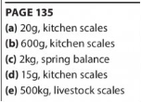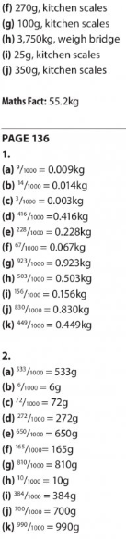 | 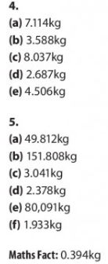  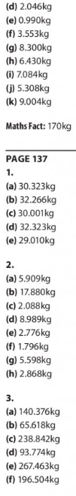
Busy At Maths Answers
Weight Chapter 25 p135, 136, 137

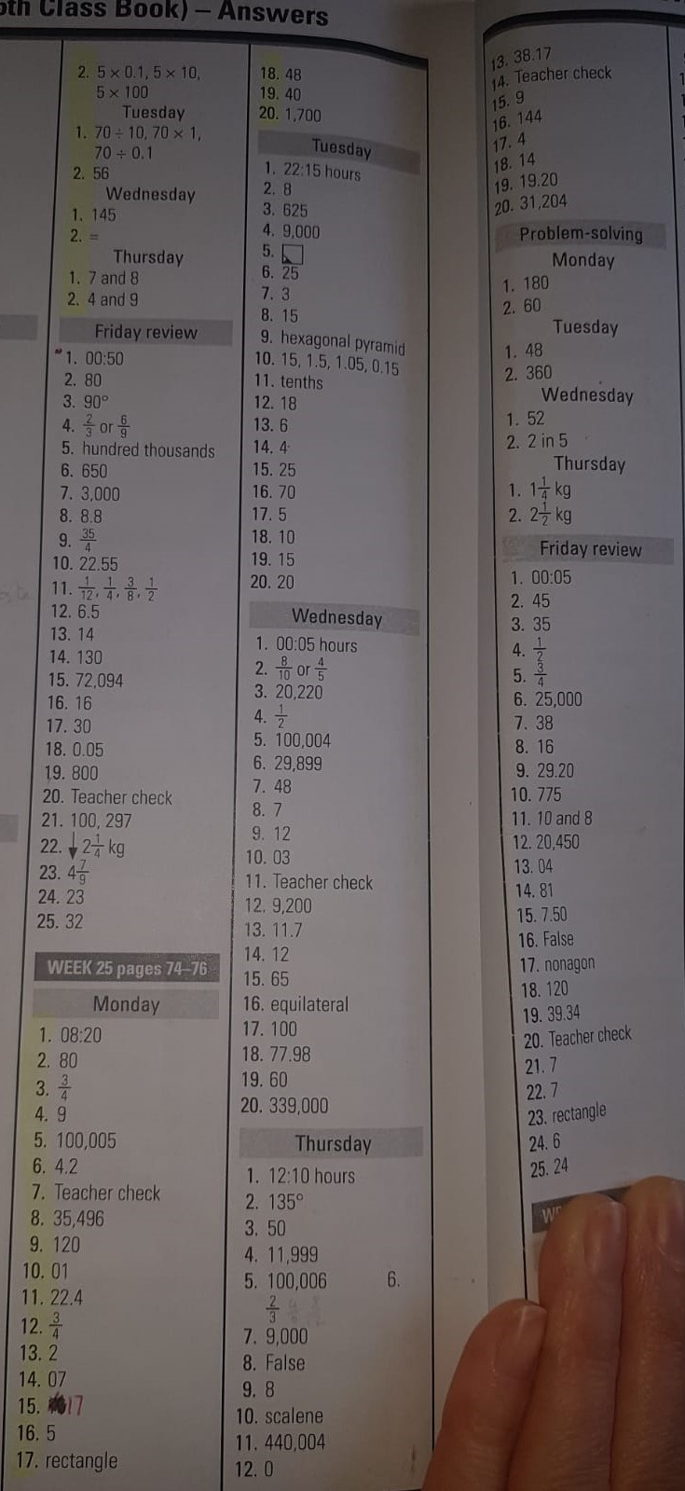
MENTAL MATHS WEEK 25

