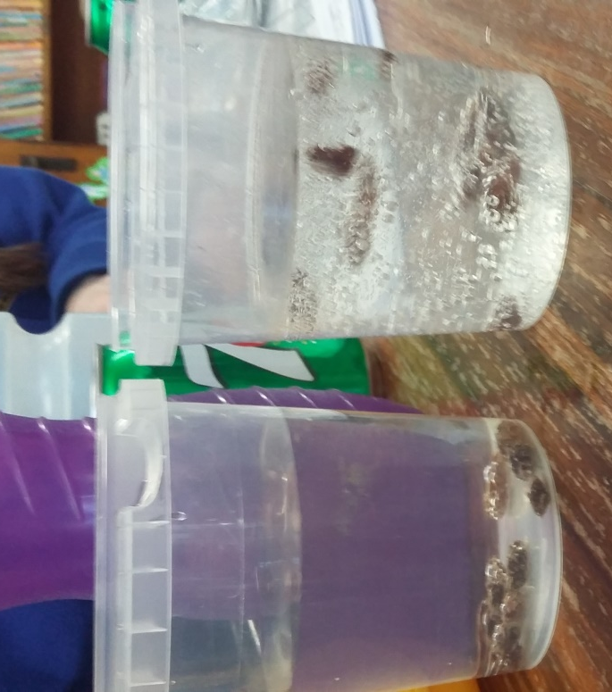
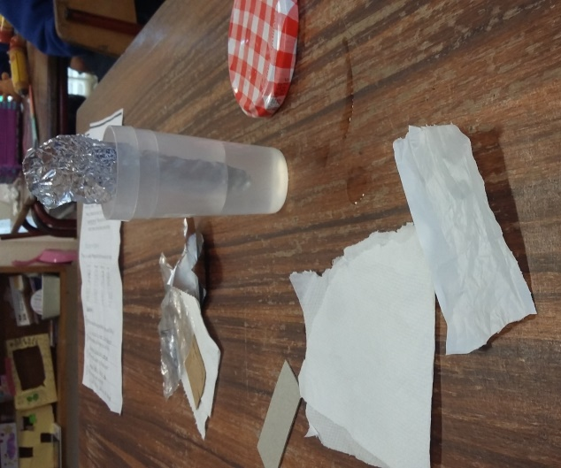

Investigating materials; transparent/opaque
and waterproof materials
Dancing raisins; sinking and floating experiment
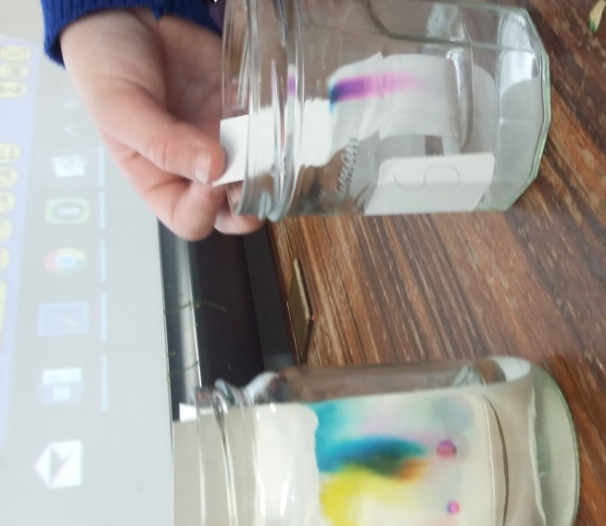
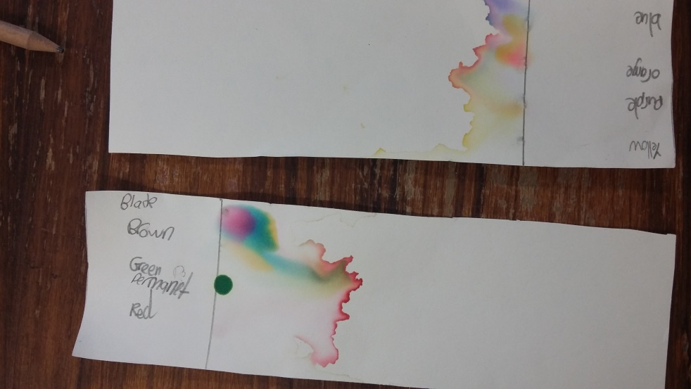
Chasing colours experiment; watch the colours spread

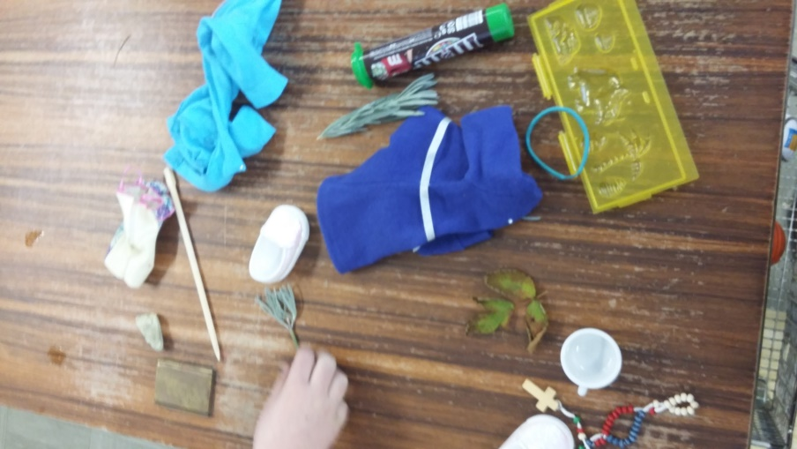
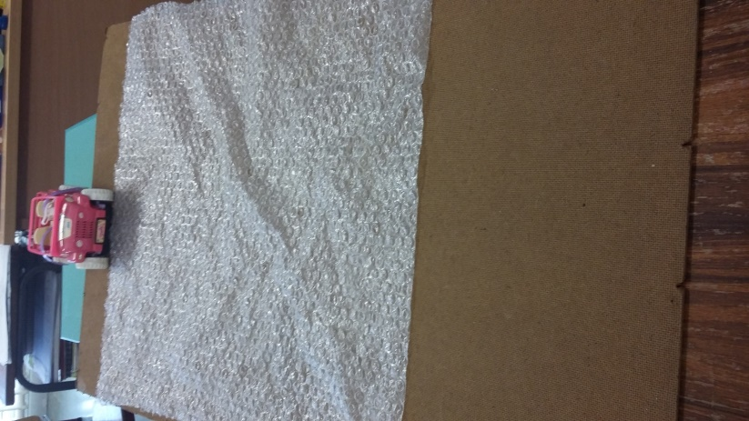
Investigating materials; man-made and natural materials and what they are made from
Push or pull; investigating surfaces
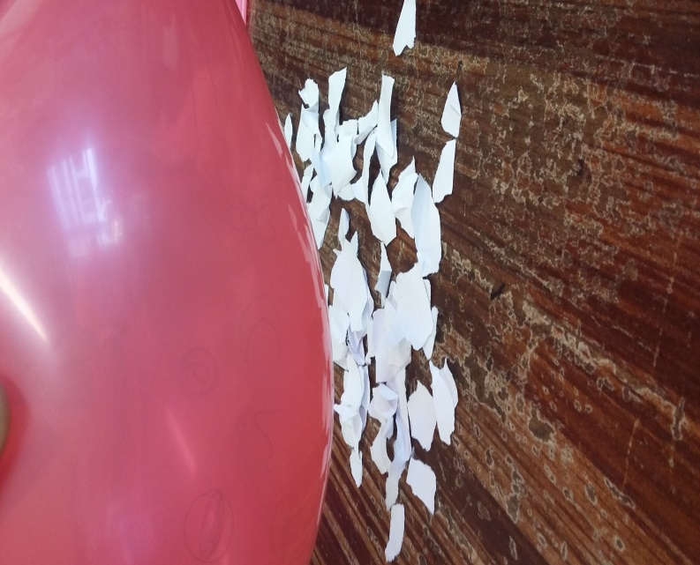
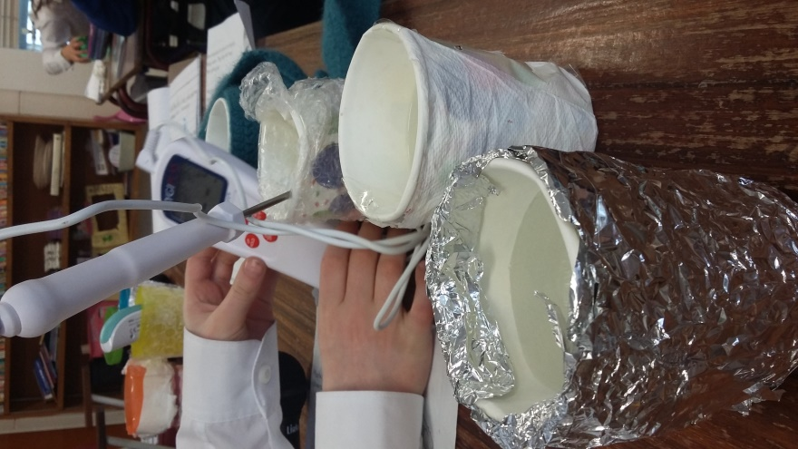

Static electricity; watch the paper jump
Insulators; what materials keep in heat?
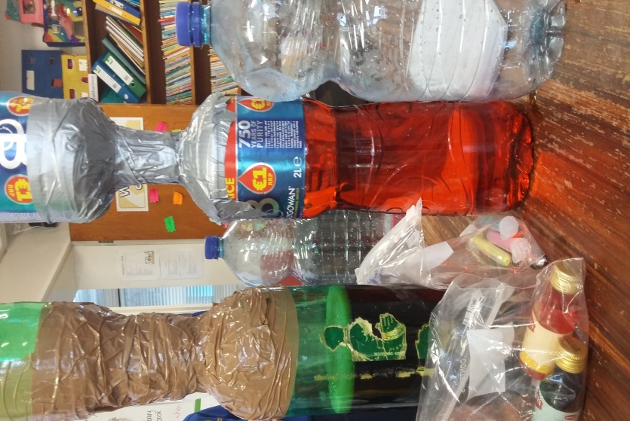
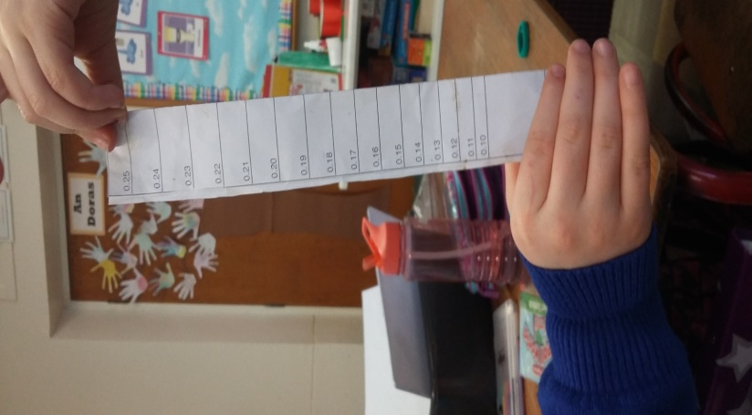
Reaction times.. how good is your reaction?
Tornado in a bottle; watch the glitter swirl around and around

